**电子设计自动化（EDA）实验报告**

实验题号 :实验十三

项目名称 : SOPC嵌入式系统外设接口控制

系班 :计算机科学与技术非师范班

学号 : 1191002005

姓名 : 陈馨

实验日期 : 2021-11-27

指导老师 ：邱德慧

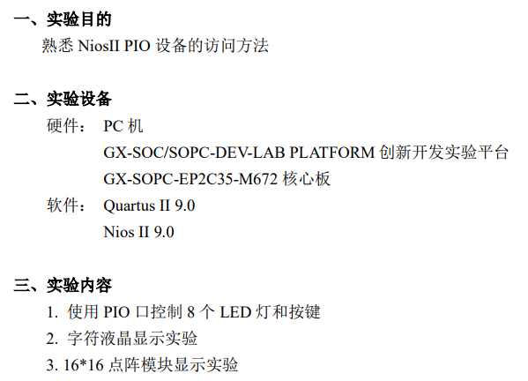

实验报告

1. LED
2. 跑马灯

**#include** "system.h"

**#include** "altera_avalon_pio_regs.h"

**#include** "alt_types.h"

**int** main (**void**) __attribute__ ((weak, alias ("alt_main")));

**void** delay (**void**)

{

alt_u32 i=0, j=0;

**while** (i<200000)

i++;

**while** (j<200000)

j++;

**return**;

}

**int** alt_main (**void**)

{

alt_u16 led = 0x2;

alt_u8 dir = 0;

/*

* Infinitely shift a variable with one bit set back and forth, and write

* it to the LED PIO. Software loop provides delay element.

*/

**while** (1)

{

**if** (led & 0x81)

{

dir = (dir ^ 0x1);

}

**if** (dir)

{

led = led >> 1;

}

**else**

{

led = led << 1;

}

IOWR_ALTERA_AVALON_PIO_DATA(LED_PIO_BASE,led);

delay();

}

**return** 0;

}

1. 按键控制

**#include** "system.h"

**#include** "altera_avalon_pio_regs.h"

**#include** "alt_types.h"

**int** main (**void**) __attribute__ ((weak, alias ("alt_main")));

**int** alt_main (**void**)

{

alt_u8 button ;

/*

* Infinitely shift a variable with one bit set back and forth, and write

* it to the LED PIO. Software loop provides delay element.

*/

**while** (1)

{

button=IORD_ALTERA_AVALON_PIO_DATA(BUTTON_PIO_BASE) ;

IOWR_ALTERA_AVALON_PIO_DATA(LED_PIO_BASE,button) ;

}

**return** 0;

}

1. LCD

代码：

**#include** <stdio.h>

**#include** "system.h"

**#include** "altera_avalon_pio_regs.h"

**#include** "alt_types.h"

**#include** <unistd.h>

**#include** <string.h>

**unsigned** **char** seg[]={'1','2','3','4','5','6','7','8','9','0','a','b','c','d','e','f', 'g','h','i','j','k','l','m','n','o','p','q','r','s','t','u','v'};

**void** Write_data(alt_u8 data)

{

IOWR_ALTERA_AVALON_PIO_DATA(TFT_LCD_RS_BASE,1);

IOWR_ALTERA_AVALON_PIO_DATA(TFT_LCD_NWR_BASE,0);

IOWR_ALTERA_AVALON_PIO_DATA(TFT_LCD_DATA_BASE,data); //地址计数器自动加1，显示屏不移动

IOWR_ALTERA_AVALON_PIO_DATA(TFT_LCD_NRD_BASE,1);

IOWR_ALTERA_AVALON_PIO_DATA(TFT_LCD_NRD_BASE,0);

usleep(1000);

}

**void** Write_cmd(alt_u8 cmd)

{

IOWR_ALTERA_AVALON_PIO_DATA(TFT_LCD_RS_BASE,0);

IOWR_ALTERA_AVALON_PIO_DATA(TFT_LCD_NWR_BASE,0);

IOWR_ALTERA_AVALON_PIO_DATA(TFT_LCD_DATA_BASE,cmd); //地址计数器自动加1，显示屏不移动

IOWR_ALTERA_AVALON_PIO_DATA(TFT_LCD_NRD_BASE,1);

IOWR_ALTERA_AVALON_PIO_DATA(TFT_LCD_NRD_BASE,0);

usleep(1000);

}

**void** initial(**void**)

{

Write_cmd(0x3c);

Write_cmd(0x06);

Write_cmd(0x0e);

Write_cmd(0x01);

}

**int** main()

{

**unsigned** **char** data_index;

**unsigned** **char** add_first,add_second;

initial(); //初始化LCD

data_index=0;add_first=0x80;add_second=0xC0;

**while**(data_index<=15) //第一行显示

{

Write_cmd(add_first+data_index);

Write_data(seg[data_index]);

data_index++;

}

**while**(data_index<=31) //第二行显示

{

Write_cmd(add_second+data_index-16);

Write_data(seg[data_index]);

data_index++;

}

**return** 0;

}

实验结果：

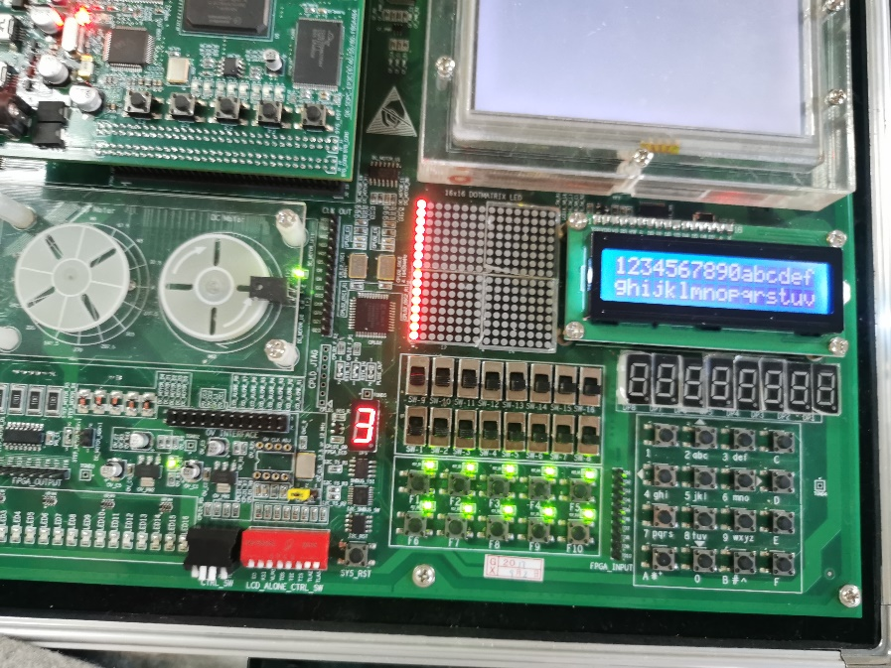

【注意】

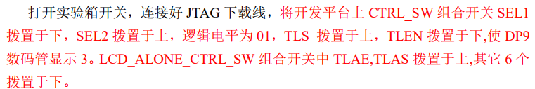

1. 点阵

代码：

**#include** "system.h"

**#include** "altera_avalon_pio_regs.h"

**#include** "alt_types.h"

alt_u16 row_num[2][16]= {{0x7FFF,0x4088,0x4208,0x5D8C,

0x6079,0x0082,0x10C4,0x1398,

0x0C90,0xF080,0x5080,0x17FF,

0x1080,0x1090,0x1088,0x1086},//chen

{0x0010,0x0062,0x47A2,0x5524,

0x5564,0xF36F,0x5555,0x5555,

0x57FD,0x04E5,0x0D55,0xFB6D,

0x8A6F,0x8A64,0xF524,0x1926} // xin

};

**int** main()

{

alt_u8 col_num,read_data;

**while**(1)

{

read_data=IORD_ALTERA_AVALON_PIO_DATA(BUTTON_PIO_BASE) ;

**for**(col_num=0;col_num<16;col_num++)

{

IOWR_ALTERA_AVALON_PIO_DATA(ROW_BASE,0);

IOWR_ALTERA_AVALON_PIO_DATA(COL_BASE,col_num) ;

**if**(read_data==0xfe){

IOWR_ALTERA_AVALON_PIO_DATA(ROW_BASE,row_num[0][col_num]);

}**else**{

IOWR_ALTERA_AVALON_PIO_DATA(ROW_BASE,row_num[1][col_num]);

}

usleep(1);

}

}

**return** 0;

}

实验结果：

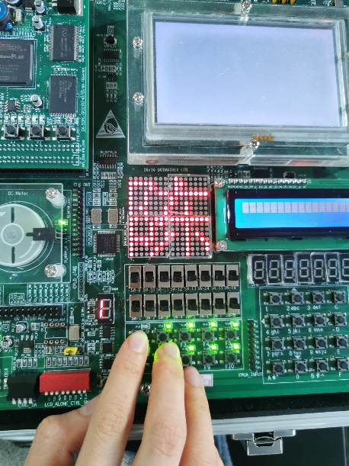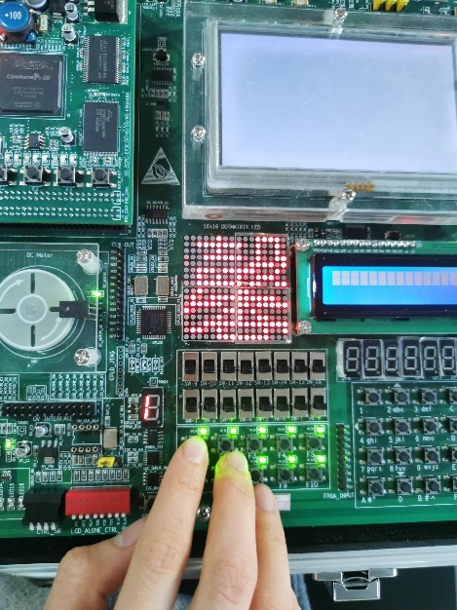

顶层模块：

